实验报告（Lab 5）
姓名：曾泇睷 学号：1820221053
实验：Basic RIP Configuration and Analysis
Lab 5-1 BASIC RIPV1 CONFIGURATION
Requirements
The network topology is shown in Figure 5-1. Four routers are used to interconnect the networks of different departments on the campus. Please configure RIPv1 on the four routers to implement communication between departments A, B and loopback 0 (where loopback 0 simulates a host on the network of other departments).
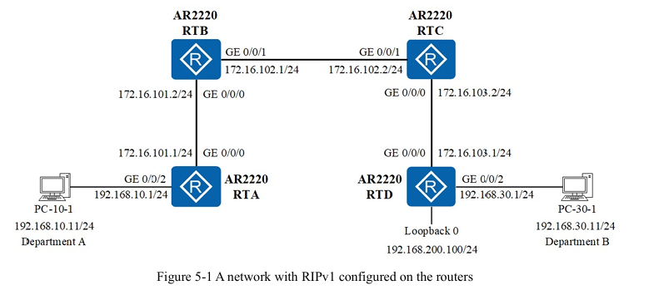
Step 1: Load the topology.
Step 2: Start devices.
Step 3: Assign IP addresses to interfaces on the routers.
Step 4: Configure the default routes and basic RIPv1 on the routers.
Step 5: Examine and verify RIPv1 configurations.
Step 6: Analyze RIPv1 traffic.
Answer the following questions:
Q5-1.1. Paste the screenshot of the created topology.
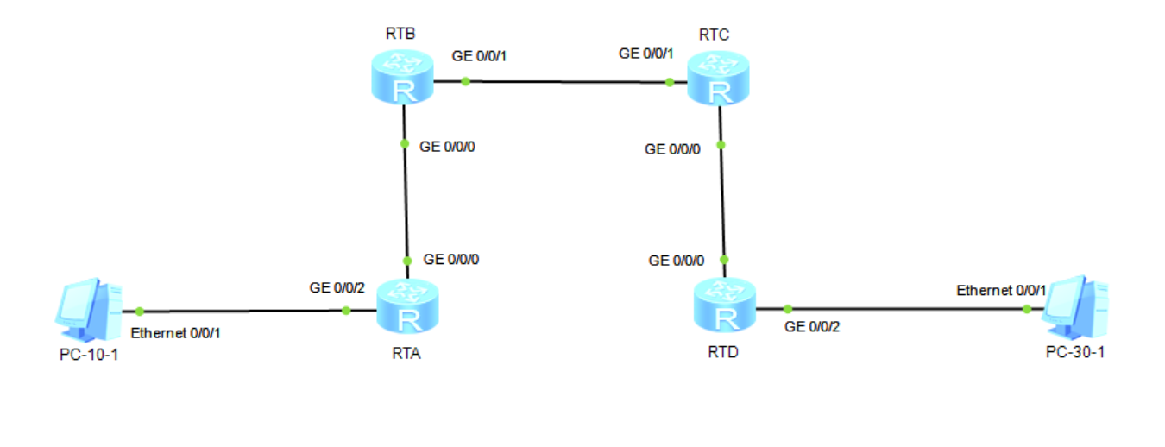
Q5-1.2. Paste the screenshot of the IP routing table on the router RTA. Highlight the RIPv1 routes in the screenshot. Which routes are learned from the RIP neighbors?
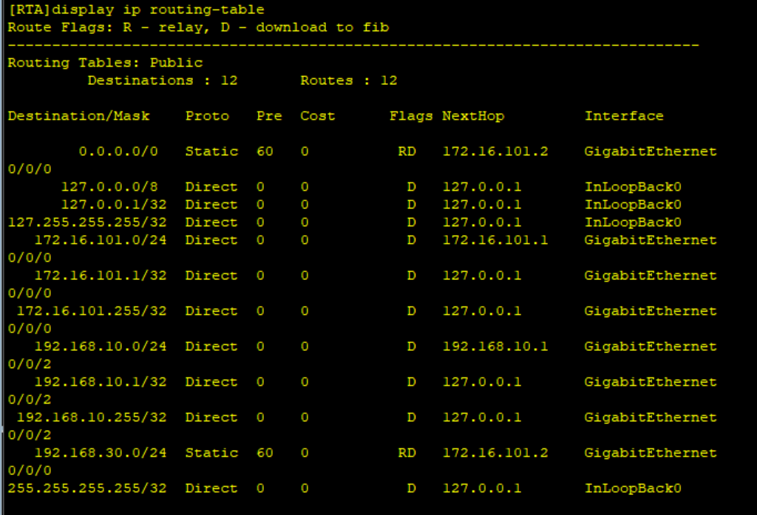
Q5-1.3. Paste the screenshot of the IP routing table on the router RTB. Highlight the RIPv1 routes in the screenshot. Which routes are learned from the RIP neighbors?
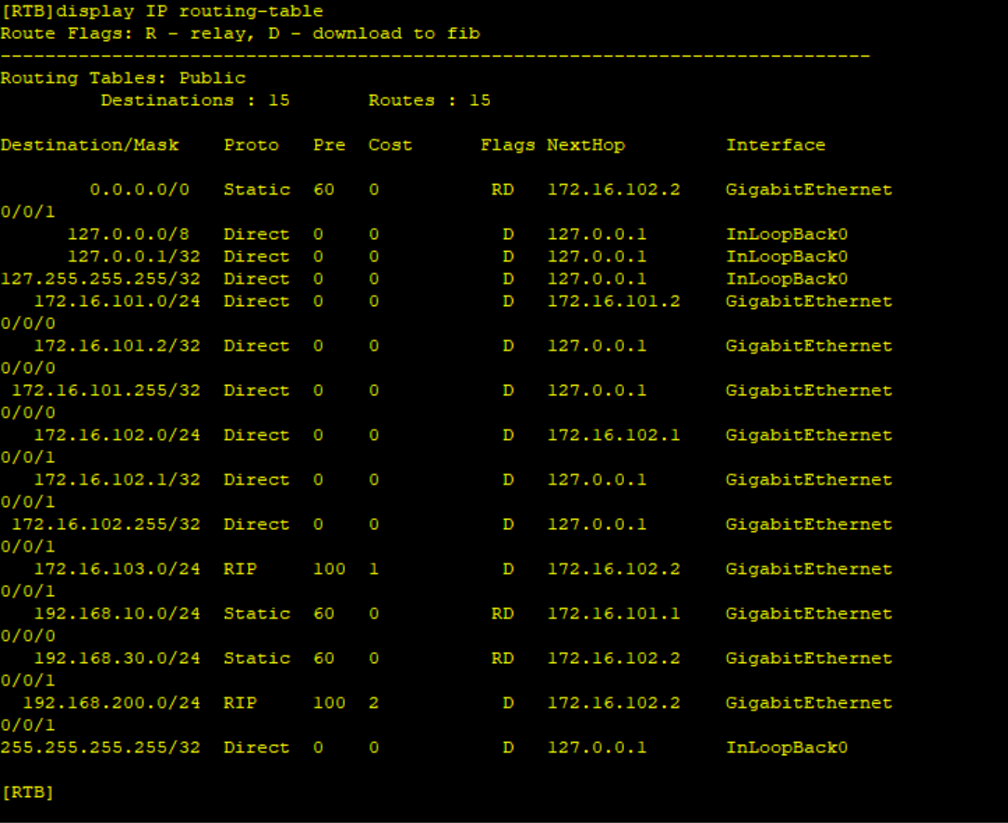
Q5-1.4. Paste the screenshot of the IP routing table on the router RTC. Highlight the RIPv1 routes in the screenshot. Which routes are learned from the RIP neighbors?
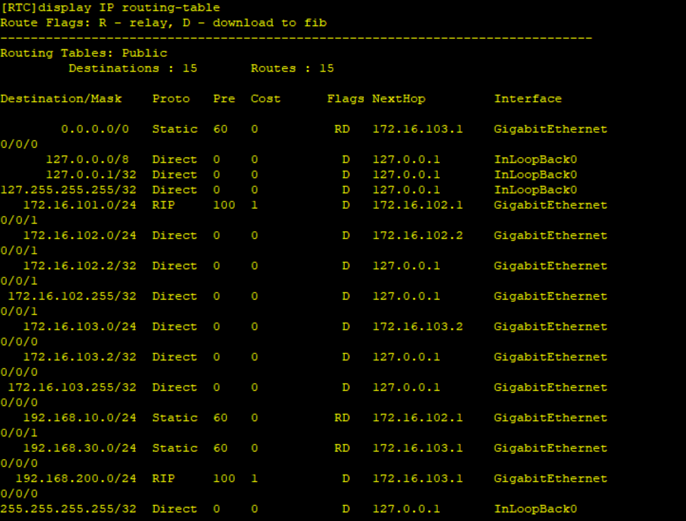
Q5-1.5. Paste the screenshot of the IP routing table on the router RTD. Highlight the RIPv1 routes in the screenshot. Which routes are learned from the RIP neighbors?
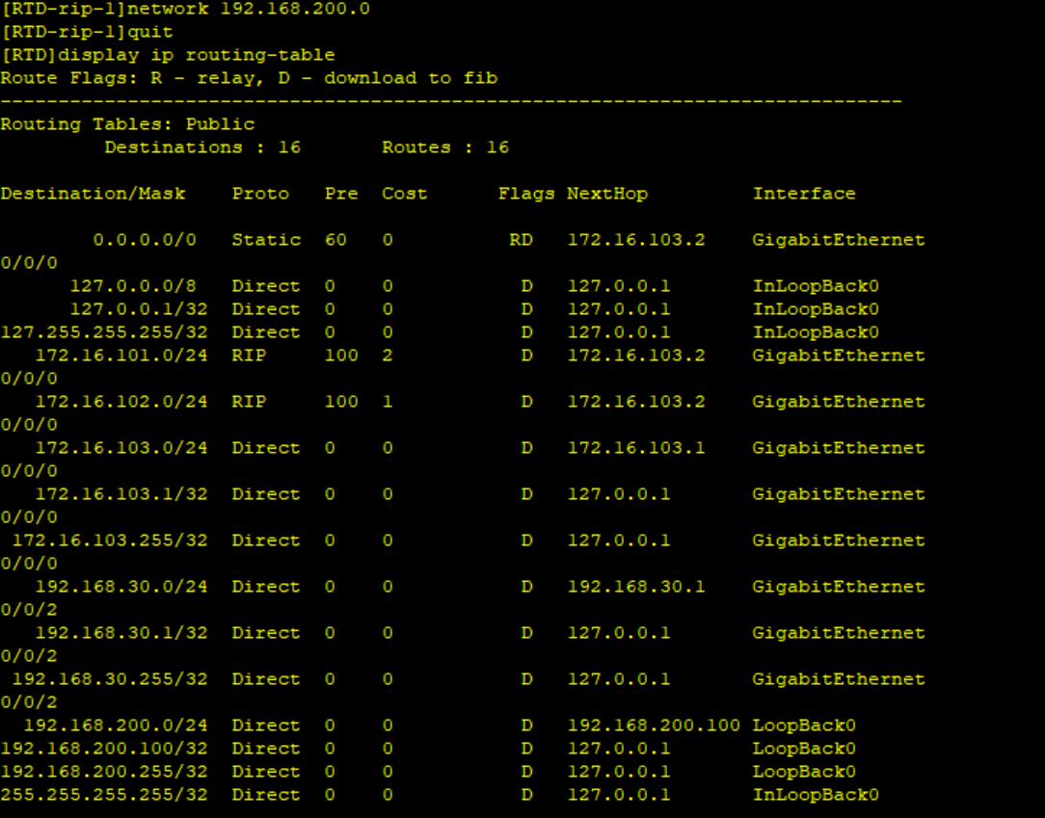
Q5-1.6. Can PC-10-1 and PC-30-1 ping each other? Please paste the screenshot of the ping result.
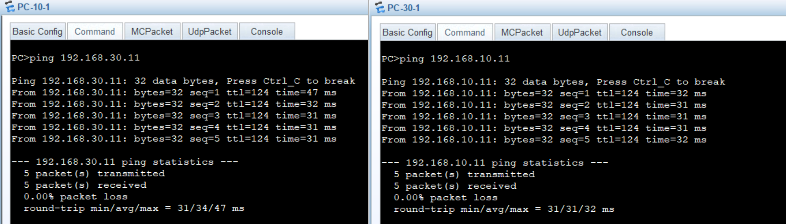
Q5-1.7. Can PC-10-1 and loopback 0 on RTD ping each other? Please paste the screenshot of the ping result.
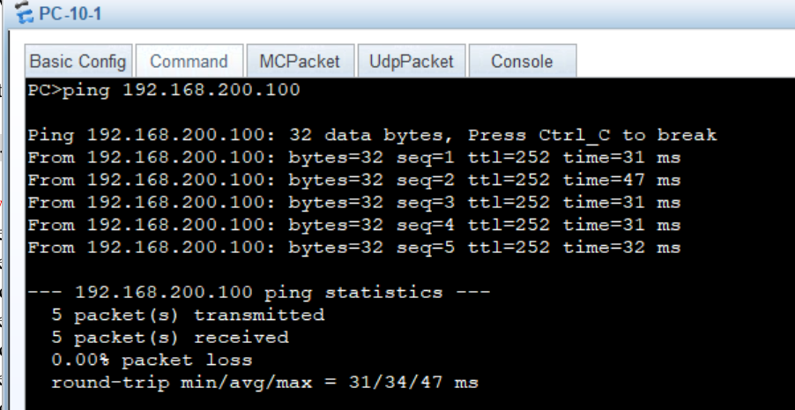
Q5-1.8. Please paste the screenshot of the result of command “tracert 192.168.30.11” issued from PC-10-1.
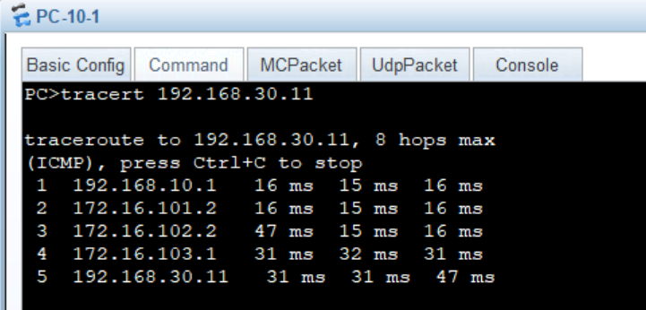
Q5-1.9. How many types of RIPv1 packets are there? What are they?
Answer:
2 types：Request: Asks for routing updates、Response: Advertises routes (every 30 seconds).

Q5-1.10. What is the interval between RIPv1 routing updates?
30 seconds

Q5-1.11. Which protocol does RIPv1 use to transmit RIP packets? What are the source port number and destination port number?
Protocol: UDP、Source/Dest Port: 520

Q5-1.12. When RIPv1 sends a routing update message, what is the destination IP address of the message? What type of IP address is it?
255.255.255.255，Broadcast

Q5-1.13. How many routes are there in each RIPv1 route update message? What information does each route contain in the route update message? Please paste the screenshot of the route information contained in the captured update routing message.
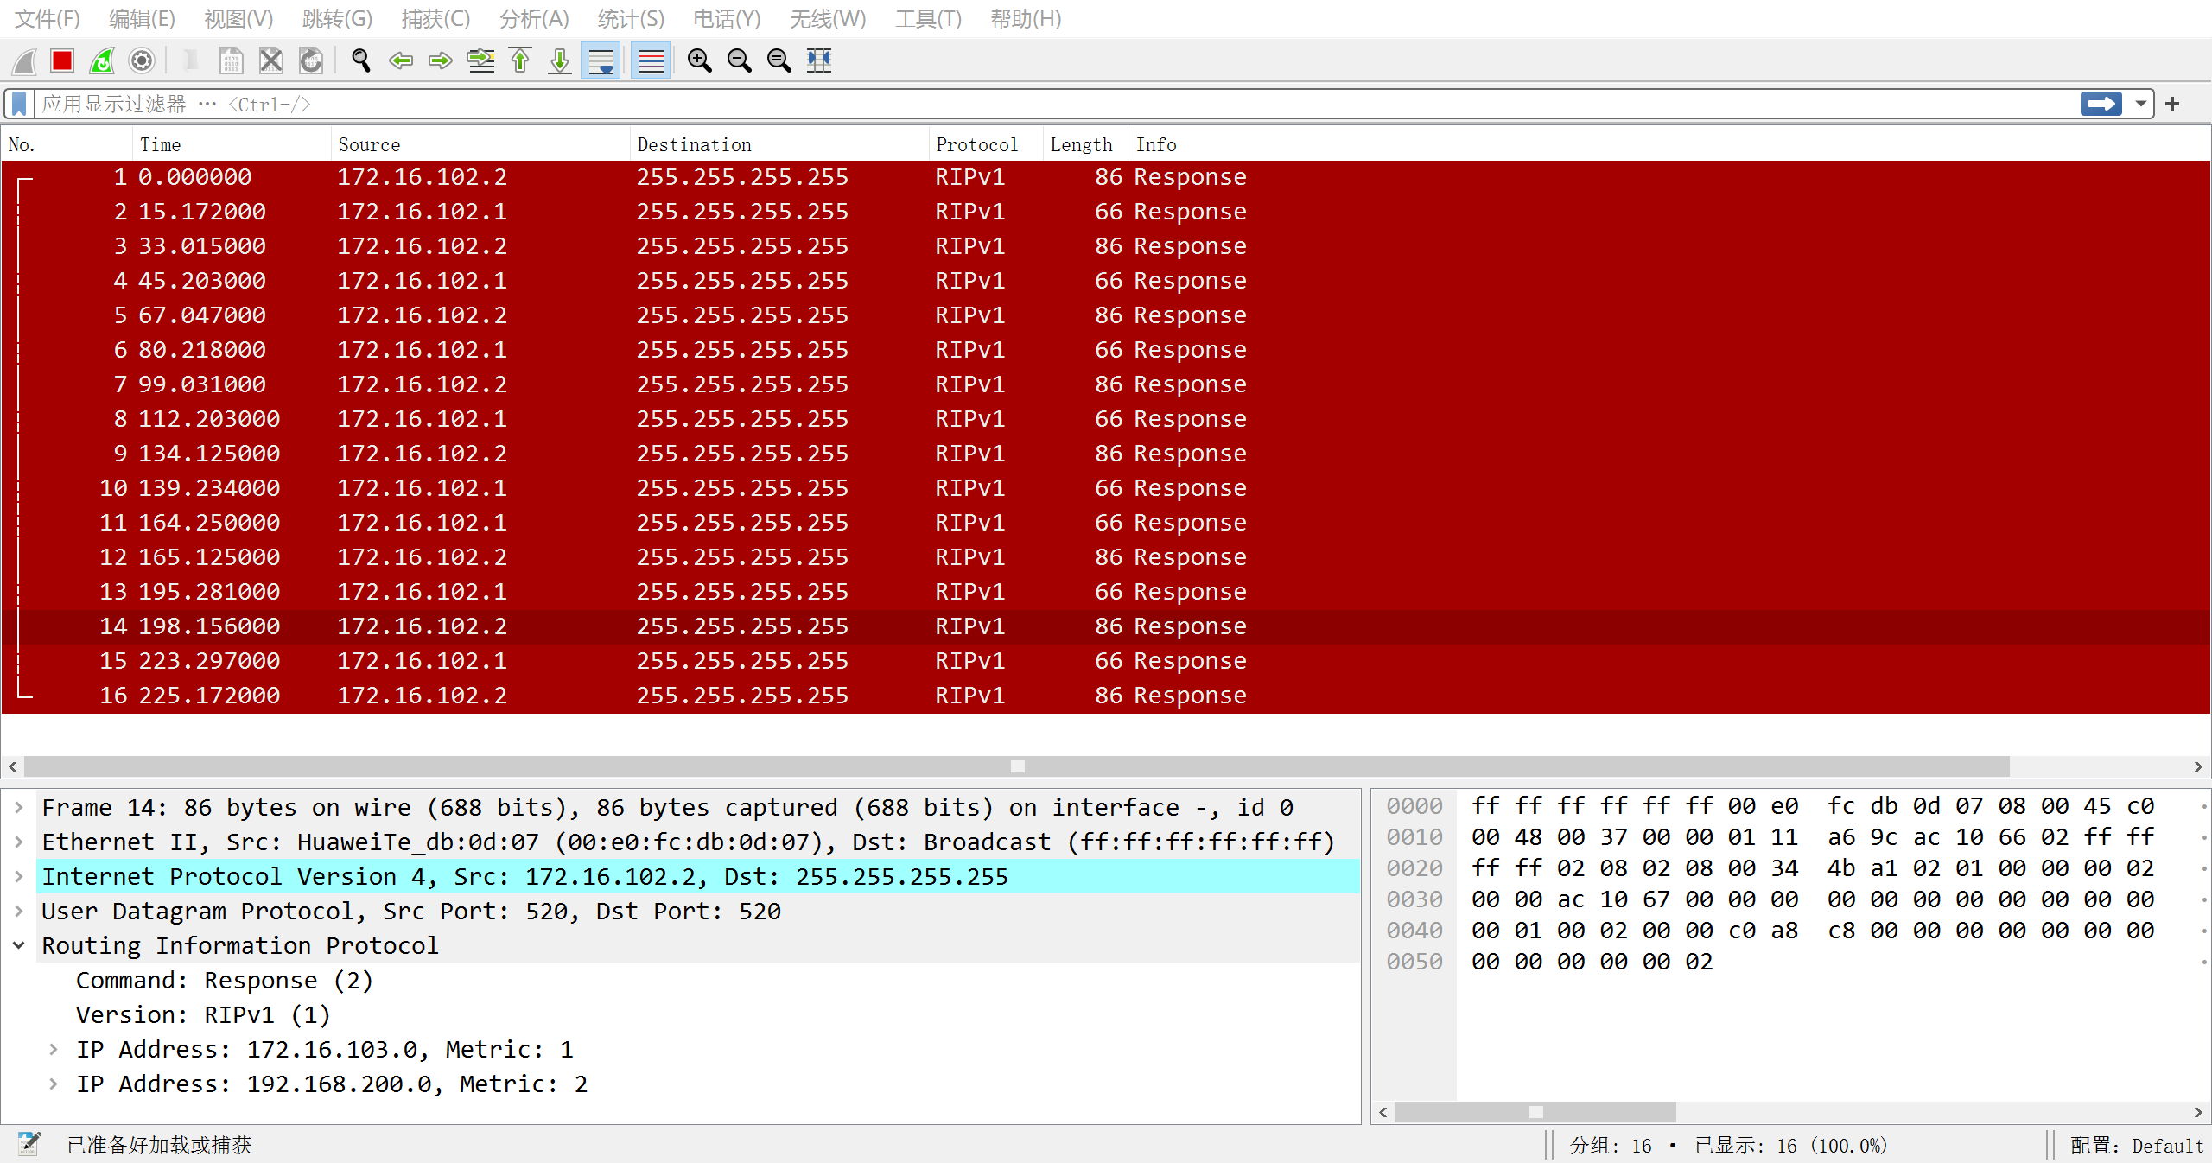
Q5-1.14. Please give the format of RIPv1 routing update message.
